**PROJECT REPORT**

(SIX WEEK TRAINING)

## emailPLUS

(Window Application)



Submitted by

**Vishal Gupta Simrandeep Singh**

**Roll No 100903114 Roll No 100903105**

Under the Guidance of

# Mr. Satnam Singh

**Alpha Net Technologies Pvt Ltd., Chandigarh**

Submitted To

# Department Of Computer Science and Engineering

**THAPAR UNIVERSITY, PATIALA**

**(Deemed University)**

**ANEXURE VIII**

# DECLARATION

I hereby declare that the project work entitled **EmailPLUS** is an authentic record of my own work carried out at **Alpha Net Technologies Pvt Ltd., Chandigarh** as requirements of semester project term for the award of degree of B.E. (Computer Science & Engineering), Thapar University, Patiala, under the guidance of **Mr. Satnam Singh**, during Jun to July, 2011.

Vishal Gupta Simrandeep Singh

100903114 100903105

Date: ___________________

Table of Contents

|  |  |  |
| --- | --- | --- |
| **SNo** | **Particulars** | **Page No** |
| 1. | Acknowledgment | **4** |
| 2. | Abstract & Preface | **5** |
| 3. | Overview of Java | **7** |
| 4. | MySQL server | **14** |
| 5. | Overview of Project | **17** |
| 6. | Planning Phase | **19** |
| 7. | Development Operation & Maintenance Environment | **21** |
| 8. | System Outline View | **23** |
| 9. | Design Phase | **25** |
| 10. | Data Flow Diagram’s (DFD’s) | **27** |
| 11. | Database Model | **32** |
| 12. | System Implementation and Testing | **33** |
| 13. | Bibliography | **?** |

#### ACKNOWLEDGEMENT

It is my pleasure to acknowledge the help, that I had received from different individuals and Alpha Net Technologies during the project based training period.

My first sincere appreciation and gratitude goes to respected **Mr. Satnam Singh**, Project guide, Alpha Net Technologies for his guidance, constructive comments, valuable suggestions and inspirations. During the entire training session, I have received endless help from him.

Also, it gives me immense pleasure to express my sincere and wholehearted sense of gratitude to my esteemed Head Training (Alpha Net Technologies Pvt. Ltd.) **Mr. Vinay Mohan Sharma**, for their invaluable and untiring guidance and supervision throughout our training Period. To derive benefits of their enormous experience, it is a matter of great privilege for me.

I also take this opportunity to express my sincere thanks and full appreciation to **Mr. Veenu Sharma** (Internal Guide), who extended his wholehearted cooperation, moral support and rendering ungrudging assistance whenever and wherever need arisen. I am very thankful to him.

Finally, I wish to say thanks to all people of the company for their kind cooperation.

**Abstract & Preface**

**emailPLUS** is an window application which allows its users to connect with any mail server and retrieve e-mails from his/her mail account using *POP3 protocol.*

This application will allow its users to compose and send mail using *SMTP protocol*. Users will be able to configure any mail account with this applications to retrieve emails.

It is developed to provide a graphical user interface to connect to any mail server using a single interface/platform.

This application will provide support to maintain details of the mails sent through.

Only registered users can use this application.

It will be developed using Java technologies.

**Objective**

The **objective** of the system is to:

1. Provide graphical user interface to connect to any Mail Server such as Gmail, Yahoo.

2. To access more than one mail accounts using a single interface/platform.

3. To provide graphical user interface to compose and send mails to different email- ids.

4. Maintain history of all the activities of users of this application.

**Introduction to programming & development environment**

**Introduction to JAVA**

**Introduction**

Java is an object-oriented programming language with a built-in application programming interface (API) that can handle graphics and user interfaces and that can be used to create applications or applets. Because of its rich set of API's, similar to Macintosh and Windows, and its platform independence, Java can also be thought of as a platform in itself. Java also has standard libraries for doing mathematics.

Much of the syntax of Java is the same as C and C++. One major difference is that Java does not have pointers. However, the biggest difference is that you must write object oriented code in Java. Procedural pieces of code can only be embedded in objects. In the following we assume that the reader has some familiarity with a programming language. In particular, some familiarity with the syntax of C/C++ is useful.

In Java we distinguish between applications, which are programs that perform the same functions as those written in other programming languages, and applets, which are programs that can be embedded in a Web page and accessed over the Internet. Our initial focus will be on writing applications. When a program is compiled, a byte code is produced that can be read and executed by any platform that can run Java.

## Characteristics:

### Platform independent

Java is a platform for application development. A platform is a loosely defined computer industry buzzword that typically means some combination of hardware and system software that will mostly run all the same software.

Java byte code is exactly the same on every platform. Java programs that have been compiled into byte code still need an interpreter to execute them on any given platform. The interpreter reads the byte code and translates it into the native language of the host machine on the fly. Since the byte code is completely platform independent, only the interpreter and a few native libraries need to be ported to get Java to run on a new computer or operating system.

All these pieces, the javac compiler, the java interpreter, the Java programming language, and more are collectively referred to as Java.

### Object oriented

In object-oriented programs data is represented by objects. Objects have two sections, fields (instance variables) and methods. Fields tell you what an object is. Methods tell you what an object does. These fields and methods are closely tied to the object's real world characteristics and behavior. When a program is run messages are passed back and forth between objects. When an object receives a message it responds accordingly as defined by its methods.

### Robust

Java implements a robust exception handling mechanism to deal with both expected and unexpected errors. The worst that an applet can do to a host system is bringing down the runtime environment. It cannot bring down the entire system.

Most importantly Java applets can be executed in an environment that prohibits them from introducing viruses, deleting or modifying files, or otherwise destroying data and crashing the host computer. A Java enabled web browser checks the byte codes of an applet to verify that it doesn't do anything nasty before it will run the applet.

### Multithreaded

Java is inherently multi-threaded. A single Java program can have many different threads executing independently and continuously. Three Java applets on the same page can run together with each getting equal time from the CPU with very little extra effort on the part of the programmer.

### High performance

Java byte codes can be compiled on the fly to code that rivals C++ in speed using a "just-in-time compiler." Several companies are also working on native-machine-architecture compilers for Java. These will produce executable code that does not require a separate interpreter, and that is indistinguishable in speed from C++.

### Dynamic

Java programs carry with them substantial amounts of run-time type information that is used to verify and resolve accesses to objects at run-time. This makes it possible to dynamically link code in a safe and expedient manner. The java programming language is unusual than other programming languages it first compiles and then interprets the program. Compile first translate the program into intermediate language called intermediate language called java byte code. Java byte code is platform independent code, which is further interpreted by the interpreter on the java platform. Interpreter parses and run each java byte code instruction on the computer. Compilation occurs only once, interpretation occurs each time when the program is executed.

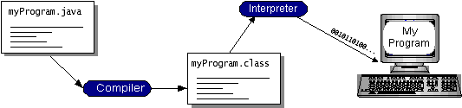

Java byte code helps in making the program “write once, run anywhere”. The program can be compiled into byte code by any platform that is having the java compiler; the compiled java byte code program is ready to run on any machine having the java virtual machine (JVM). JVM is an interpreter for byte code.

## Java is too effective:

Java has caused more excitement than any development on the Internet since Mosaic. Java was the first way to include inline sound and animation in a web page. Java also lets users interact with a web page. Instead of just reading it and perhaps filling out a form, users can now play games, calculate spreadsheets, chat in real-time, get continuously updated data and much, much more.

Here are just a few of the many things Java can do for a web page:

* Inline sounds that play in real-time whenever a user loads a page
* Music that plays in the background on a page
* Cartoon style animations
* Real-time video
* Multiplayer interactive games

**What makes Java special?**

Java is a programming language for distributed applications. It doesn't just allow you to add new types of content to your pages like Netscape and Internet Explorer do. Rather it lets you add both the content and the code necessary to interact with that content.

e.g. let’s say you want to use EPS files on your Web site. Previously you had to wait until at least one web browser implemented EPS support. Now with the help of java you can write your own code to view EPS files and send it to any client that requests your page at the same time they request the EPS file.

E.g. suppose you want people to be able to search your electronic card catalog. However the card catalog database exists on a mainframe system that doesn't speak HTTP. Before Java you could hope that some browser implemented your proprietary card catalog protocol or you could try to program some intermediate cgi-bin on a UNIX box that can speak HTTP and talk to the card catalog, not an easy task. With Java when a client wants to talk to your card catalog you can send them the code they need to do so. You don't have to try to force things through an httpd server on port 80 that were never meant to go through it.

If that were all Java was, it would still be more interesting than a <marquee> or <frame> tag in some new browser beta.

Java is platform independent. A Java program can run equally well on any architecture that has a Java enabled browser. With the release of Netscape Navigator 2.0 that includes Windows 95, Windows NT, the MacOS, Sun Solaris, Sun OS 4.1.3, SGI IRIX, OSF/1, HP-UX with more to come.

Java isn't just for web sites. Java is a programming language that lets you do almost anything you can do with a traditional programming language like Fortran or C++. However Java has learned from the mistakes of its predecessors. It is considerably cleaner and easier to use than those languages.

**Advantages of Java**

* **Simple**

Java has the bare bones functionality needed to implement its rich feature set. It does not add lots of syntactic sugar or unnecessary features.

* **Object-Oriented**

Almost everything in Java is either a class or a method or an object. Only the most basic primitive operations and data types (int, for, while, etc.) are at a sub-object level.

* **Platform Independent**

Java programs are compiled to a byte code format that can be read and run by interpreters on many platforms including Windows 95, Windows NT, and Solaris 2.3 and later.

* **Safe**

Java code can be executed in an environment that prohibits it from introducing viruses, deleting or modifying files, or otherwise performing data destroying and computer crashing operations.

* **High Performance**

Java can be compiled on the fly with a Just-In-Time compiler (JIT) to code that rivals C++ in speed.

* **Multi-Threaded**

Java is inherently multi-threaded. A single Java program can have many different things processing independently and continuously.

**Java platform**

A java platform is the hardware or software environment in which a program runs. The java platform has two components:

* Java Virtual Machine (JVM)
* Java Application Programming Interface (Java API)

JVM is a standardized hypothetical computer, which is emulated inside your computer by a program.

Java Source Code

Java Compiler

Java Object Code

Java Virtual Machine

Java interpreter

The program executed

By the interpreter

Computer Operating System

The **Java API** is a large collection of ready-made software components that provide many useful capabilities, such as graphical user interface (GUI). The java API is grouped into libraries of related classes and interfaces these libraries are known as packages.

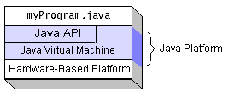

**Programming language**

* **Java language fundamentals**

Java is purely object-oriented programming language.

Java is neither a superset nor a subset of C / C++.

C++

C

Java

## 

## Java and C

* + Java does not include keywords like *goto* , *sizeof*  and *typedef*.
  + Java does not contain data types like struct*,* *union* and *enum.*
  + Java does not define the type modifiers keywords like *auto*, *register*, signed.
  + Java does not support an explicit pointer type.
  + Java does not have preprocessor.
  + Java does not support variables arguments to functions.
  + Java adds many features required for Object-Oriented Programming.
* **Java and C++**
* Java does not support operator overloading.
* Java does not support multiple inheritances.
* Java does not support global variables.
* Java has replaced the destructor function with a finalize() function.
* Java is a true object-oriented language while C++ is basically C with object-oriented extension.
* Java does not provide the access to the pointers.

#### General Style

In order to write a program in Java, one has to follow the well-defined structure of the Java program and should have the basic idea of all the programming constructs like statements, tokens, etc.

Following points are to be noted:

* Java is case-sensitive language.

In Java, uppercase and lowercase letters are not the same.

* Java is freeform language.

Freeform means that one need not have to indent any lines to make the program work properly, but it is good practice to use indent to make the program readable.

**Introduction to MySQL**

# Introduction to MYSQL

MySQL, the most popular Open Source SQL database management system, is developed, distributed, and supported by Oracle Corporation. The MySQL (R) software delivers a very fast, multi-threaded, multi-user, and robust SQL (Structured Query Language) database server. MySQL Server is intended for mission-critical, heavy-load production systems as well as for embedding into mass-deployed software.

The MySQL software is Dual Licensed. Users can choose to use the MySQL software as an Open Source/Free Software product under the terms of the GNU General Public License or can purchase a standard commercial license.

The MySQL web site (http://www.mysql.com/) provides the latest information about the MySQL software.

* MySQL is a relational database management system.

A database is a structured collection of data. It may be anything from a simple shopping list to a picture gallery or the vast amounts of information in a corporate network. To add, access, and process data stored in a computer database, you need a database management system such as MySQL Server. Since computers are very good at handling large amounts of data, database management systems play a central role in computing, as standalone utilities, or as parts of other applications.

* MySQL software is Open Source.

A relational database stores data in separate tables rather than putting all the data in one big storeroom. This adds speed and flexibility. The SQL part of “MySQL” stands for “Structured Query Language.” SQL is the most common standardized language used to access databases and is defined by the ANSI/ISO SQL Standard. The SQL standard has been evolving since 1986 and several versions exist.

* The MySQL Database Server is very fast, reliable, and easy to use.

MySQL Server was originally developed to handle large databases much faster than existing solutions and has been successfully used in highly demanding production environments for several years. Although under constant development, MySQL Server today offers a rich and useful set of functions. Its connectivity, speed, and security make MySQL Server highly suited for accessing databases on the Internet

* MySQL Server works in client/server or embedded systems.

The MySQL Database Software is a client/server system that consists of a multi-threaded SQL server that supports different backends, several different client programs and libraries, administrative tools, and a wide range of application programming interfaces (APIs).

MySQL Server also provides an embedded multi-threaded library that you can link into your application to get a smaller, faster, easier-to-manage standalone product.

* A large amount of contributed MySQL software is available.

### The Main Features of MySQL

* Internals and Portability
* Column Types
* Commands and Functions
* Security
* Scalability and Limits
* Connectivity
* Localization

**EmailPLUS**

(Window Interface to Mail Server With Spam Filter)

**Introduction**

**emailPLUS** is an window application which allows its users to connect with any mail server and retrieve e-mails from his/her mail account using *POP3 protocol.*

This application will allow its users to compose and send mail using *SMTP protocol*. Users will be able to configure any mail account with this applications to retrieve emails.

It is developed to provide a graphical user interface to connect to any mail server using a single interface/platform.

This application will provide support to maintain details of the mails sent through.

Only registered users can use this application.

It will be developed using Java technologies.

**PLANNING PHASE**

**Problem Recognition**

A problem is well defined very rarely. It corps out with a vague feeling of some statements that lead to vague conclusions. So the first task is to get more crucial information by interviewing and meeting concerned people. It clarifies how the problem is felt, how often it occurs, how it affects the business and which departments are suffering with this. This phase consists of the following tasks.

* **Problem Definition And Initial Investigation**

This was a preliminary investigation done with a view to have a “feel” of the working of the proposed system. This phase has been identified the end-user directly involved in the system who were the managers, assistant officer and database administrator, and the development department. By understanding the working of database, its flow and also after conducting meetings and interviews with the concerned persons of the department, a clear idea about the working was obtained. A flexible approach is adapted towards people who are interviewed. Short hand written notes are prepared based on the response of the employees. The interviews are preferably conducted at the work place of the person being interviewed. Detailed investigation is done in order to define the scope of the problem .The interview is concluded with a quick resume of the ground covered during the interview .The Questionnaire technique is combined with interviews to get the best result. Proper care has been taken in the design of such questionnaires so that the persons answering these questions do not feel hesitant. An explanatory note that serves to gain cooperation and avoid misunderstanding by setting out the purpose of the exercise clearly accomplishes each questionnaire.

***Observation technique***is also used for fact finding. The work described at the time of interview is observed personally ads it reduces the chances of misunderstanding and omissions. Some important things observed are like the flow of information through the system and important data transactions, the data being maintained and the frequency of their updating.

By the end of this phase, idea as to how the information enters the system, how it is stored, how it is processed, how information changes affects the working of the system and finally the output format required by the end-user was collected. All the information generated from this phase acted as an input to the next phase.

* **Feasibility Study**

A feasibility study is a test of a system proposal according to its workability impact on organization, ability to meet user needs and effective use of resources. The objective of a feasibility study is not to solve a problem but to acquire a sense of its scope. During the study, the problem definition is crystallized and the aspects of the problem to be included in the system are determined. After the initial investigation of the system that helped to have in-depth study of the existing system, understanding its strength and weaknesses and the requirements for the new proposed system.

Feasibility study was done in three phases documented below.

**a)** **Behavioral feasibility**: People are inherently resistant to change and computers have been known to facilitate change. There is always some reluctance among the users against the introduction of new system but they were told that this system would eliminate the unnecessary overhead of database migration and conversion, which presently had to be carried out on daily basis to facilitate transactions between the different departments. The objective this feasibility phase is to take the operational staff into confidence. As the success of a good system depends upon the willingness of the operating staff, they were taken into full confidence that the new proposed system would make their jobs easier, relieve them from the unnecessary overheads and reduce the possibility of errors creeping into the system.

**b) Economic feasibility:** Economic feasibility is the most frequently used method for evaluating the effectiveness of the candidate system. More commonly known as cost\benefit analysis, the procedure is to determine the benefits and savings that are expected from a candidate system and compare them with the costs. If benefits outweigh the costs, then the decision is made to design and implement the system. A cost\benefit analysis was done for the proposed system to evaluate whether it would be economically viable or not. The organization has in store many machines with high processing power necessary to implement the system. Also the organization has necessary software i.e.tomcat5.0, j2ee1.4, mysql or hardware to support the system. Considering the programmer time and the negligible hardware/software cost required for developing the system, it was found that the benefits in terms of reduced overhead as a result of elimination of the requirement of database migration and conversion was more than the cost.

**c) Technical feasibility**: Technical feasibility centers on the existing computer system. (Hardware/software) and to what extent it can support the proposed addition also the organization already has sufficient high-end machines to serve the processing requirements of the proposed system. So there is no need to purchase new software as the organization has necessary software i.e. JRE, mysql or hardware to support the proposed system. Having gone through the steps of the overall analysis and feasibility study the next step was to carry out a detailed system analysis. The project analysis phase was conducted to learn about the proposed system, to study the problems and finally select a system that would take care of the problems identified in the working of the present system.

**ANALYSIS PHASE**

Systems analysis is the study of sets of interacting entities, including computer systems analysis. This field is closely related to operations research. It is also "an explicit formal inquiry carried out to help someone (referred to as the decision maker) identify a better course of action and make a better decision than he might otherwise have made."

*Analysis is defined as the procedure by which we break down an intellectual or substantial whole into parts so that we can achieve our end goals.*

The development of a computer-based information system includes a systems analysis phase which produces or enhances the **data model** which itself is a precursor to creating or enhancing a **database**. There are a number of different approaches to system analysis. When a computer-based information system is developed, systems analysis would constitute the following steps:

* The development of a feasibility study, involving determining whether a project is economically, socially, technologically and organizationally feasible.
* Conducting fact-finding measures, designed to ascertain the requirements of the system's end-users. These typically span interviews, questionnaires, or visual observations of work on the existing system.
* Gauging how the end-users would operate the system (in terms of general experience in using computer hardware or software), what the system would be used for etc.

Another view outlines a phased approach to the process. This approach breaks systems analysis into 5 phases:

* Scope definition
* Problem analysis
* Requirements analysis
* Logical design
* Decision analysis

**Use case** are a widely-used systems analysis modeling tool for identifying and expressing the functional requirements of a system. Each use case is a business scenario or event for which the system must provide a defined response. Use cases evolved out of object-oriented analysis.

**Detailed Study of the Existing System**

This phase provides the overall requirement for the system what is to be done. Input for this phase is the information collected through several data collecting schemes such as survey, cross-questioning-answering etc and the raw data obtained which is not properly ordered and not in the precise manner. So here this raw data is converted into useful information written in precise manner and thus output is a formal document. After collecting all the information and requirements, they were verified from the concerned persons by presenting a diagrammatic version of the proposed system. The points missing were added to the system specifications for the desired system. So this final document provides the system requirement specifications for the desired system. It helps in reducing the total development cost and also establishes the various points for validation and verification.

**User Requirement**

Since end users are the ones who are finally going to use the system, their requirements need to be identified. This involves questioning the end users what their expectations were. The main requirement of the end user is that the system should be easy to use and take less time. In addition to these another important factor was to eliminate the need for database conversion and migration that had to be carried out presently. After conducting interviews with the users a document called the software requirement specification was created. This is the most important document that forms the basis for system development. It should be consistent, complete, unambiguous, traceable and inter-related.

This document has the following components.

* **Functional Requirements:** The functional requirements specify relationship between the inputs and outputs. All the operations to be performed on the input data to obtain output are to be specified. This includes specifying the validity checks on the input and output data, parameters affected by the operations and the other operations, which must be used to transform the inputs into outputs. Functional requirements specify the behavior of the system for valid input and outputs.
* **Performance Requirements**

This section includes performance of the product that are set by user interaction and studying the existing system of the organization. These are stated in complete measurable terms, so that they can be verified during system evaluation phase. Some of the performance requirements are stated below.

1. **User Friendly:** the system produced is user friendly, understandable and easy to use so that the users of the system can easily learn to use the system. For this the system is made menu-driven with well-documented programs.
2. **Time Element (response and processing time):** the response time of the system is very less and takes less time to execute queries and triggers.
3. **Maximum Throughput:** the system gives maximum throughput with relevant output
4. **Robustness:** the system will be able to handle undesirable situations and errors encountered at various levels e.g. if the user supplies invalid input for processing, the system gracefully halts, displaying a message to the user indicating the cause of the error and prompting him it enter the correct input.
5. **Flexibility:** the system is flexible in nature so that likely changes and alterations can easily be made.
6. **Information Security:** records in the system must be safe, confidential and must be prevented from unauthorized access.
7. **Moral and User Satisfaction:** system will be able to satisfy the user requirements; this is the main and conspicuous measure of the system performance. Also the system must raise the moral of the user. The higher the moral, greater the expected work performance level.

* **External Interfaces and Data Flow**

This heading specifies the externally observable characteristics of the software product. Several graphical tools are used to express the requirements of a system rather than writing long lines of text. These are very effective tools for use during the system analysis phase.

* **User Displays**

These are extremely useful tools for interactive applications where fast response is needed. The user displays consist of screens that help in designing a menu driven system. The menus attached to the screens help in making a system interactive and user friendly by providing an easy to use point and click interface to the application. These menus consist of a list of options from which the user can choose an action depending on the task to be performed. So these forms or so called user displays is the key to the success of the entire system.

**Development, Operation and Maintenance Environments**

* **Development Environment**

Having constant interaction with the users as well as management aids in the system development. The logical user suggestions sure certainly welcomed and considered. There is a multi-user environment in the organization. For the development of new system mysql, rdbms package, tomcat server for server side programming will be used and Microsoft front page, java server pages and java script for client side programming and will be used to provide GUI to system.

* **Operating Environment**

The input data required are obtained from the documents, which contains all the details of the transactions. After validation and relevant processing, the data is to be stored in the database. The user selects the desired database table on after which the query is formulated. The query is generated by filtering the database based on the user defined conditions and constraints. The formulated query is executed on the database to obtain the required information.

* **Maintenance Environment**

The proper maintenance of the new system is very important for its smooth working. The maintenance of the software is to be done by the system analyst and programmers in the organization. But for hardware maintenance engineer may be called from where hardware was purchased.

**Objectives of the Proposed System**

The development of the proposed system is done keeping in view the problems in the existing system. The proposed system will not only overcome the limitations of the present system but will also provide the following characteristics:

The **objective** of the system is to:

1. Provide graphical user interface to connect to any Mail Server such as Gmail, Yahoo.

2. To access more than one mail accounts using a single interface/platform.

3. To provide graphical user interface to compose and send mails to different email- ids.

4. Maintain history of all the activities of users of this application.

**System Outline View**

After firming the requirements of the system, the summary chart or data flow diagram (DFD) of the proposed system is prepared. This gives the brief of the system with respect to the inputs being considered, the outputs reports, the data being transformed and the main processed involved in the system.

The **Inputs** required for this system are:

* Login
* User Information
* Mail Server connection detail

The **Outputs** required for this system:

* Retrieve & view emails from mail server.
* Compose and send mail using email account on mail server.
* Listing of user activities.
* Listing of user details.
* Details of data sent using emailPLUS.
* User Maintenance
* Reports.

**Software and Hardware Specification**

* **Software Requirements:**

1. JDK 1.6
   * + NetBeans 6.5.1
2. Jdbc Driver for MySQL Database Server
   * + mysql-connector-java-5.1.7-bin.jar
3. Database Server
   * + MySQL Database Server 5.0
4. Operating system
   * + Windows Vista / XP / 7 / Linux Fedora 11

* **Hardware Requirements:**

1. Intel P4 processor with minimum 2.0Ghz Speed
2. RAM: Minimum 512MB
3. Hard Disk: Minimum 20GB

**Design Phase**

After the analysis phase we have with us the details of the existing system and the requirements of the user for the new system. This phase diverts focus from the problem domain to the solution domain. It acts as a bridge between the requirement phase and its solution. The design phase focuses on the detailed implementation of the system recommended in the feasibility study. Emphasis is on translating performance specifications into design specifications.

Systems design is the process or art of defining the architecture, components, modules, interfaces, and data for a system to satisfy specified requirements. One could see it as the application of systems theory to product development. There is some overlap with the disciplines of systems analysis, systems architecture and systems engineering.

#### The External Design

External design consists of conceiving, planning out and specifying the externally observable characteristics of the software product. These characteristics include user displays or user interface forms and the report formats, external data sources and the functional characteristics, performance requirements etc. External design begins during the analysis phase and continues into the design phase.

#### Logical design

The logical design of a system pertains to an abstract representation of the data flows, inputs and outputs of the system. This is often conducted via modelling, which involves a simplistic (and sometimes graphical) representation of an actual system. In the context of systems design, modelling can undertake the following forms, including:

* 1. Data flow diagrams
  2. Entity Life Histories
  3. Entity Relationship Diagrams

#### Physical design

The physical design relates to the actual input and output processes of the system. This is laid down in terms of how data is input into a system, how it is verified/authenticated, how it is processed, and how it is displayed as output.

Physical design, in this context, does not refer to the tangible physical design of an information system. To use an analogy, a personal computer's physical design involves input via a keyboard, processing within the CPU, and output via a monitor, printer, etc. It would not concern the actual layout of the tangible hardware, which for a PC would be a monitor, CPU, motherboard, hard drive, modems, video/graphics cards, USB slots, etc.

**Design Methodology: Rapid Application Development (RA**D)

Rapid Application Development (RAD) is a methodology in which a systems designer produces prototypes for an end-user. The end-user reviews the prototype, and offers feedback on its suitability. This process is repeated until the end-user is satisfied with the final system.

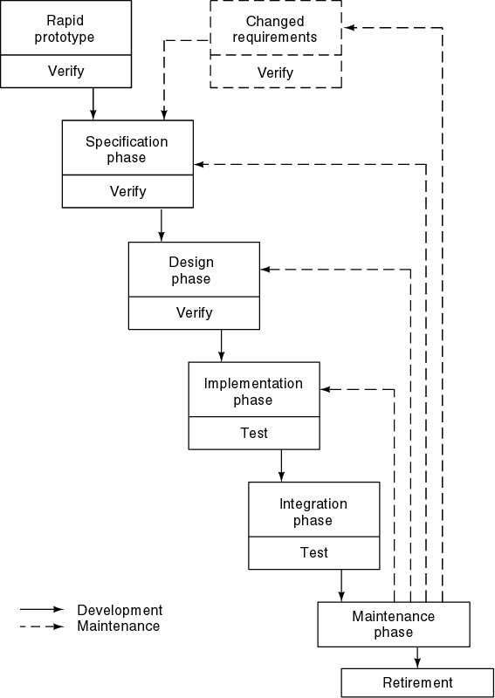

**Data Flow Diagrams :**

**1) Login :**

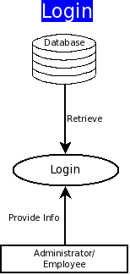

**2) emailPLUS:**

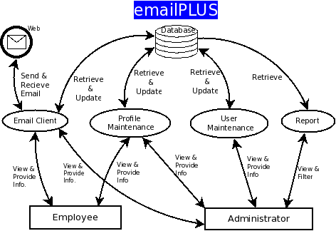

**3) Profile Maintenance**

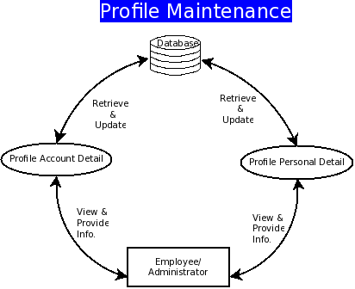

**4) Email Client:**

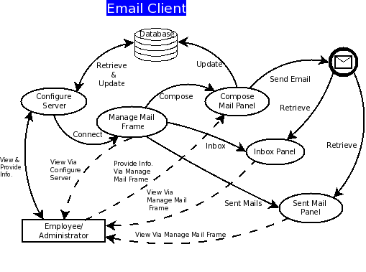

**5) User Maintenance :**

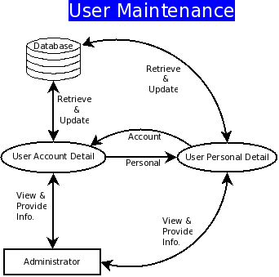

**6) Report :**

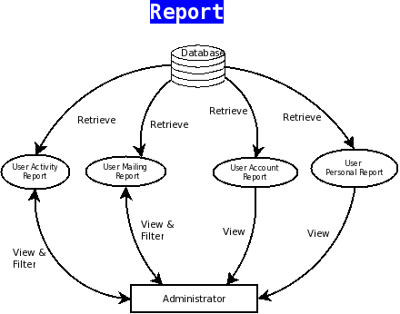

**Database Model:**

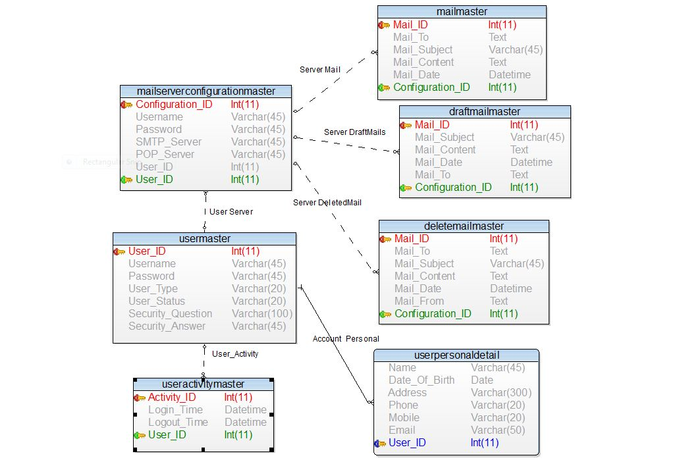

**SYSTEM IMPLEMENTATION AND TESTING**

**1. Implementation Issues**

Implementation phase of the software development is concerned with translating the design specifications into the source code. After the system has been designed, arrives the stage of putting it into actual usage known as the implementation of the system. This involves putting up of actual practical usage of the theoretically designed system. The primary goal of implementation is to write the source code and the internal documentation so that conformance of the code to its specifications can easily be verified and so the debugging, modifications and testing are eased. This goal can be achieved by making the source code as clear and as straightforward as possible. Simplicity, Elegance and Clarity are the hallmarks of good programs whereas complexity are indications of inadequate design and misdirected thinking. The system implementation is a fairly complex and expensive task requiring numerous inter-dependent activities. It involves the effort of a number of groups of people: user and the programmers and the computer operating staff etc. This needs a proper planning to carry out the task successfully. Thus it involves the following activities:

* Writing and testing of programs individually
* Testing the system as a whole using the live data
* Training and Education of the users and supervisory staff

Source code clarity is enhance buy using structured coding techniques, by efficient coding style, by appropriate supporting documents, by efficient internal comments and by features provided in the modern programming language.

The following are the structured coding techniques:

1) Single Entry, Single Exit

2) Data Encapsulation

3) Using recursion for appropriate problems

**2. Testing**

The most important activity at the implementation stage is the system testing with the objective of validating the system against the designed criteria. During the development cycle, user was involved in all the phases that are analysis, design and coding. After each phase the user was asked whether he was satisfied with the output and the desired rectification was done at the moment. During coding, generally bottom up technique is used. Firstly the lower level modules are coded and then they are integrated together. Thus before implementation, it involves the testing of the system. The testing phase involves testing first of separate parts of the system and then finally of the system as a whole. Each independent module is tested first and then the complete system is tested. This is the most important phase of the system development. The user carries out this testing and test data is also prepared by the user to check for all possible combinations of correct data as well as the wrong data that is trapped by the system. So the testing phase consists of the following steps:

* **Unit testing:**

In the bottom of coding technique, each module is tested individually. Firstly the module is tested with some test data that covers all the possible paths and then the actual data was fed to check for results.

* **Integration testing:**

After all the modules are ready and duly tested, these have to be integrated into the application. This integrated application was again tested first with the test data and then with the actual data

* **Parallel testing:**

The third in the series of tests before handling over the system to the user is the parallel processing of the old and the new system. At this stage, complete and thorough testing is done and supports out the event that goes wrong. This provides the better practical support to the persons using the system for the first time who may be uncertain or even nervous using it.

The testing will be performed considering the following points:

1) Clerical procedure for collection and disposal of results

2) Flow of data within the organization

3) Accuracy of report output

4) Software testing which involves testing of all the programs together. This involves the testing of system software utilities being used and specifically develops application software.

5) Incomplete data formats

6) Halts due to various reasons and the restart procedures.

7) Range of items and incorrect formats

8) Invalid combination of data records.

9) Access control mechanism used to prevent unauthorized access to the system.

**Results, Conclusion & future Scope of Project**

Result of above work is a window application in which

* Only authenticate users can login i.e. can send & retrieve emails from server.
* All the sent mails will be saved into the system database to maintain complete history of user activities.
* All company (one who will implement this product) employees can send mails only through this application.
* Each & every inbox mail will be evaluated by spam filter.

Future scope of the project

* Till then this product is single user standalone window application. In future versions thread technology can be added to provide multiuser capability.
* Window interface can be changed to Web Interface in next version.
* To stand with more new technology of modern world window interface can be changed to Mobile Interface.